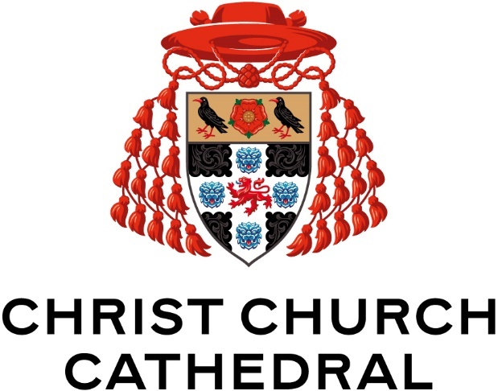

Broadcasting Policy

Virtual worship is becoming a normal part of everyday life. Christ Church Cathedral is committed to ensuring the safety of these activities for those participating.

March 2025
This document will be reviewed, revised (as required) and approved as part of the Cathedral’s annual review process
Version | Date | Reviewed by | Approved by | Date of next review
V 1 | Feb 2022 | N/A | SRH, Chapter | Feb 2023
V2 | Feb 2023 | MD, SAW | Chapter | Feb 2024
V3 | Feb 2024 | MD, SAW | Chapter | May 2024
V4 | March 2025 | LW | Chapter | March 2026
V5 | April 2026 | JD, FS | Chapter | April 2027

How we safeguard when broadcasting.
Christ Church Cathedral broadcasts are now a central part of the offering the Cathedral can make to its congregation and community. These developments are overwhelming positive, but we are also aware of the associated risks.
This good practice guidance has been compiled to help clergy, staff, volunteers who provide and use Christ Church Cathedral’s broadcasting facilities.
The Cathedral’s broadcast offering includes:

Recordings:
- Pre-recorded services and events which are recorded, edited, and released at another date on YouTube or other platform via an authorised Cathedral account; commonly known as ‘the weekly pre-record’.

Livestreams:
- Services and Events which are broadcast live on YouTube or another platform fully live and unedited.

The safety of children, young people and vulnerable adults must be maintained at all times. If a child or adult is in immediate danger, risk of harm, or requires medical attention call the emergency services on 999. Do not delay.

Broadcasting equipment
It is important that everyone follows some key rules when online. Everyone has a responsibility to themselves and to others to ensure that they are safe online. People should participate online in the same way as they would in any other public forum.

- Use of the broadcasting equipment must be booked through the Operations Manager.
- No personal profiles should be created on or logged into on the broadcast equipment by a qualified operator e.g. a personal google or one drive account.
- Broadcast operators and engineers must not log into their personal social media, email accounts, or similar on the Broadcast equipment or any other device associated with Broadcasting.
- Equipment is deployed into the Cathedral for specific broadcasting purposes only by designated operators.
- The cathedral social media platform passwords are not to be given out and only DBS trained personnel permitted access to the streaming platform.

Broadcasting choristers
The following are important to make sure that the safety of choristers is protected whilst recording and livestreaming.
- Choristers will never be identified by name on screen.
- Only services identified by the Organist (Director of Musi) to be recorded as noted on the music planner or as part of the agreed 12 annual livestreams according to the relevant Chapter Policy.
- Recordings of service for the ‘weekly pre-record’ will be edited by the Operations Manager and passed to the Sub Organist and Associate Choral Director for comment via an unlisted You Tube link. Final sign off for release is with the Organist.
- Footage folders will be password protected. Only trained and DBS checked operators can access these folders.
- No external hard drives or storage devices are to be used for the purposes of transferring or storing broadcast footage except under explicit supervision by the Operations Manager.
- Where this occurs, a separate dedicated supervised session will be encouraged for direct transfer rather than clipping a general recording
- All editing and use of footage must take place in the Cathedral Gallery or Cathedral Office. No footage may be transferred to a personal computer.

3. Information storage and sharing
- The footage folders will be password protected on the Cathedral shared drive. Only trained and DBS checked operators can access these folders. If an external party requires access, a Cathedral Team member will supervise this e.g. external audit.
- Sharing unpublished broadcast footage will not typically be undertaken except under exception and limited circumstances by private or unlisted links from the Cathedral Channel to preserve control and prevent accidental sharing e.g.:
  - Lay Clerks or others may request a short clip or footage e.g. for scholarship/audition applications from an recorded event or service from the Organist. Where this occurs, and permission is given, the Operations Manager will arrange for the footage to be clipped and available via a ‘unlisted’ or ‘private’ YouTube link on the Cathedral Channel with the following Watermark:
  - “Property of Christ Church Cathedral. Not for Public Release”
- All editing and use of footage must take place in the Gallery or Cathedral Office. No footage may be transferred to a personal computer.

4. Congregations and audiences
- Seating areas will be provided for members of the congregation or audience who do not wish to be filmed.
- Livestreaming and recording will be clearly announced at the start of services and events so that people have a chance to opt out.
- Great care will be taken to plan which services should be recorded or streamed to ensure that sensitive topics and special moments of personal worship such as the administration of Holy Communion are not compromised or broadcast publicly.

Christ Church Cathedral’s Cathedral Safeguarding Officer is Fiona Sidorowicz. Associate Safeguarding Officers are Matthew Dickins and Charlie Kerr. If you have a safeguarding concern, contact the Police on 999 if there is a risk of immediate harm, otherwise please email cathedral.safeguarding@chch.ox.ac.uk

